Ship Name:       Record Number:       Date:       Conducted by: Name:            Rank:

1. Identify work activity and the Aspect to be assessed (Personal Safety / Occupational health, Environment, Ship’s Safety or Public health)

Activity:       Aspect:

1. By applying the concept of ” What could go wrong and how could it happen ?” and/or “What If…” brain storming, Identify potential hazards
2. Identify existing control measures for each identified hazard (ie SMS procedures, checklists, written best management practices (ie through standing orders etc); control measures can be several per hazard
3. Evaluate for each identified hazard, with the existing control measures applied, its Likelihood and Severity of Harm thus determining its Risk Factor by using the 6x6 Likelihood/Severity Risk Matrix *(for Matrix and definitions of Likelihood, Severity and Risks, see overleaf)*

|  |  |  |  |  |  |
| --- | --- | --- | --- | --- | --- |
| No | Description of Identified Hazard | Existing Control Measures to Protect from Harm  (can be several per Hazard) | Likelihood of Harm | Severity of Harm | Risk Factor |
| 1 |  |  |  |  |  |
| 2 |  |  |  |  |  |
| 3 |  |  |  |  |  |
| 4 |  |  |  |  |  |
| 5 |  |  |  |  |  |
| 6 |  |  |  |  |  |
| 7 |  |  |  |  |  |
| 8 |  |  |  |  |  |
| 9 |  |  |  |  |  |
| 10 |  |  |  |  |  |
| 11 |  |  |  |  |  |
| 12 |  |  |  |  |  |
| 13 |  |  |  |  |  |
| 14 |  |  |  |  |  |

*(add more rows in table if necessary)*

**The Hazards, Controls Measures and Risk Factors are to be communicated to the persons involved in the activity (ie in a Toolbox Talk)**

1. Identify any **good practice** relevant to the activity and comply with it as additional control measures as a decision method for ALARP*
2. For Hazards with Risk Factors ABOVE 3 (ie 4. Significant, 5. High, 6. Very High), implement further control measures to reduce the risk to 3 or below
3. Determine if the extra control measures are reasonably practicable and implement those that are (unless the cost for the control measures is grossly disproportionate to the benefit of risk reduction)*

|  |  |  |  |  |  |  |  |
| --- | --- | --- | --- | --- | --- | --- | --- |
| No | Hazard with Risk factor ABOVE 3 | Risk Factor | Action date for further control measures | Further Control Measures | Re-Evaluated Likelihood | Re-Evaluated Severity | Re-Assessed Risk Factor |
| 1 |  |  |  |  |  |  |  |
| 2 |  |  |  |  |  |  |  |
| 3 |  |  |  |  |  |  |  |
| 4 |  |  |  |  |  |  |  |
| 5 |  |  |  |  |  |  |  |
| 6 |  |  |  |  |  |  |  |
| 7 |  |  |  |  |  |  |  |

*(add more rows in table if necessary)*

**The Hazards, Controls Measures and Risk Factors are to be communicated to the persons involved in the activity (ie in a Toolbox Talk)**

**\*ALARP means that the risk has been reduced to “As Low As Reasonably Practicable”**

1. If the risk cannot be reduced to 3 or below, review the actions required per the Risk categorization (see item 4 of Definitions)

Comments:

1. Review periodically, latest in 12 months :

Next Planed Assessment Date:

1. Responsible Officer :

1. Persons participating in the Risk Assessment :

**DEFINITIONS**

1. **Likelihood (of Harm):**

|  |  |  |  |  |  |  |
| --- | --- | --- | --- | --- | --- | --- |
| **Probability Chances /** | **1** | **2** | **3** | **4** | **5** | **6** |
| **Very unlikely** | **Unlikely** | **Remote** | **Occasional** | **Likely** | **Highly Likely** |
| **Occurrence** | Extremely unusual | Unlikely to occur | There is a good chance the hazard will not occur | Likely to occur | Very likely to occur | Likely to occur imminently. |
| **Frequency / Controls** | Once in a lifetime for a vessel. Control measures unlikely to fail. | Once per 15 year period for a vessel | Once per 5 year period for a vessel | Once per 2 year period for a vessel | Once per year for a vessel | There are no effective controls in place |

1. **Severity (of Harm):**

| Hazardous Occurrence | Activity Impacts: | **1** | **2** | **3** | **4** | **5** | **6** |
| --- | --- | --- | --- | --- | --- | --- | --- |
| **Minor** | **Moderate** | **Severe** | **Major** | **Critical** | **Disastrous** |
| Accident | **Occupational Health / Personal Safety (OHPS)** | At most a single minor injury or occupational illness. | Lost time injury. Illness and/or multiple minor injuries or occupational illness. | A major injury, loss of limb or disabling illness | A single death; and/or multiple severe injuries or occupational illnesses. | Greater than 1 fatality and up to 10 fatalities | More than 10 fatalities. |
| Incident | **Environmental damage (ED)** | Minor spill on the vessel that is cleaned up by the crew. | Around 50 litre spill. Minor spill where some contamination of the environment occurs. | Around 500 litre spill. Considerable environmental contamination results in a major fine imposed by the authorities. | Around 5,000 litre spill. Significant fine on vessel and/or detention order. | Around 50,000 litre spill. Significant fine, vessel detention and criminal prosecution. | Serious environmental contamination (e.g. Exxon Valdez, Torrey Canyon). Significant legal action against the company and major clean-up operation required. |
| Incident | **Safety of the Vessel / Ship Damage (SD)** | Minor damage to the ship. | Damage to the vessel which requires a repair team to be sent to the ship. | Major damage to the ship which will require dry-docking for repairs at some time. | Significant damage to the ship that requires immediate dry-docking for repair. | Critical damage to the ship where it is removed from trading for a significant period of time for repair. | Loss of the vessel. |
| Outbreak | **Public Health Outbreak (PH)** | Isolated case(s) of viral or Gastrointestinal illness within 0.5% of crew or passengers. | Sudden increase of viral or Gastrointestinal illness within 0.5% - 1.5 % of crew or passengers. | Outbreak of viral or Gastrointestinal illness within 1.5% -2.5% of crew or passengers. | Epidemic of viral or Gastrointestinal illness within 2.5 % - 10 % of crew or passengers. | Epidemic of viral or Gastrointestinal illness within 10% to 50 % of crew or passengers. | Pandemic of viral or Gastrointestinal illness above 50% of crew or passengers. |

1. **Risk Matrix (6 x 6)**

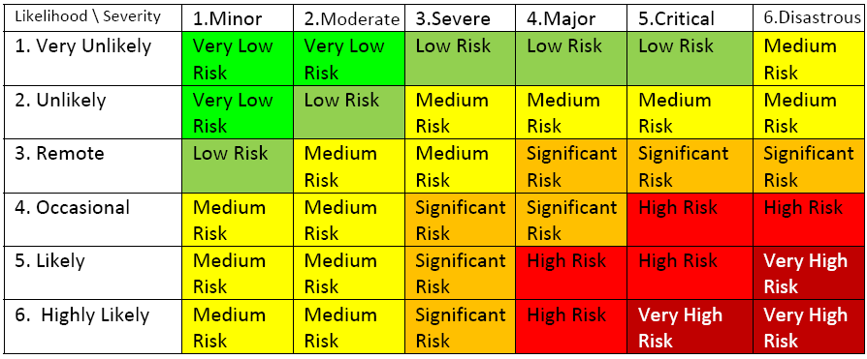

1. **Risk Categorization with Actions Required and Timelines**

|  |  |  |  |  |  |
| --- | --- | --- | --- | --- | --- |
| **Risk Categorization** | | | **Action Required** | **Controls** | **Timescale** |
| **Factor** | **Category** | **Tolerability** |
| **1** | **Very Low** | Tolerable | No further action necessary | | |
| **2** | **Low** | No additional controls are required | Monitoring is required to ensure control measures are maintained | N.A. |
| **3** | **Medium** | Actions to further reduce risk may be considered but the risk is generally acceptable | N.A. |
| **4** | **Significant** | Intolerable | Undesirable. Efforts should be made to reduce risk | Apply interim risk control measures and maintain them. | Defined time period  (max within a work shift ie max 8 hrs) |
| **5** | **High** | New work not to start until risk reduced. If work in progress, urgent action to be taken. Consider suspending or restricting the activity | Implement control measures urgently. Considerable resources may be required for control measures | Urgently within a defined time period (max within till next work break ie max 2 hrs) |
| **6** | **Very High** | Work should not be started or continued until the risk has been reduced | Substantial improvement necessary in risk control measures. Halt or prohibit the activity. | Immediately (0 hrs) till it is possible to reduce the risk |